$$ANN session-2$$

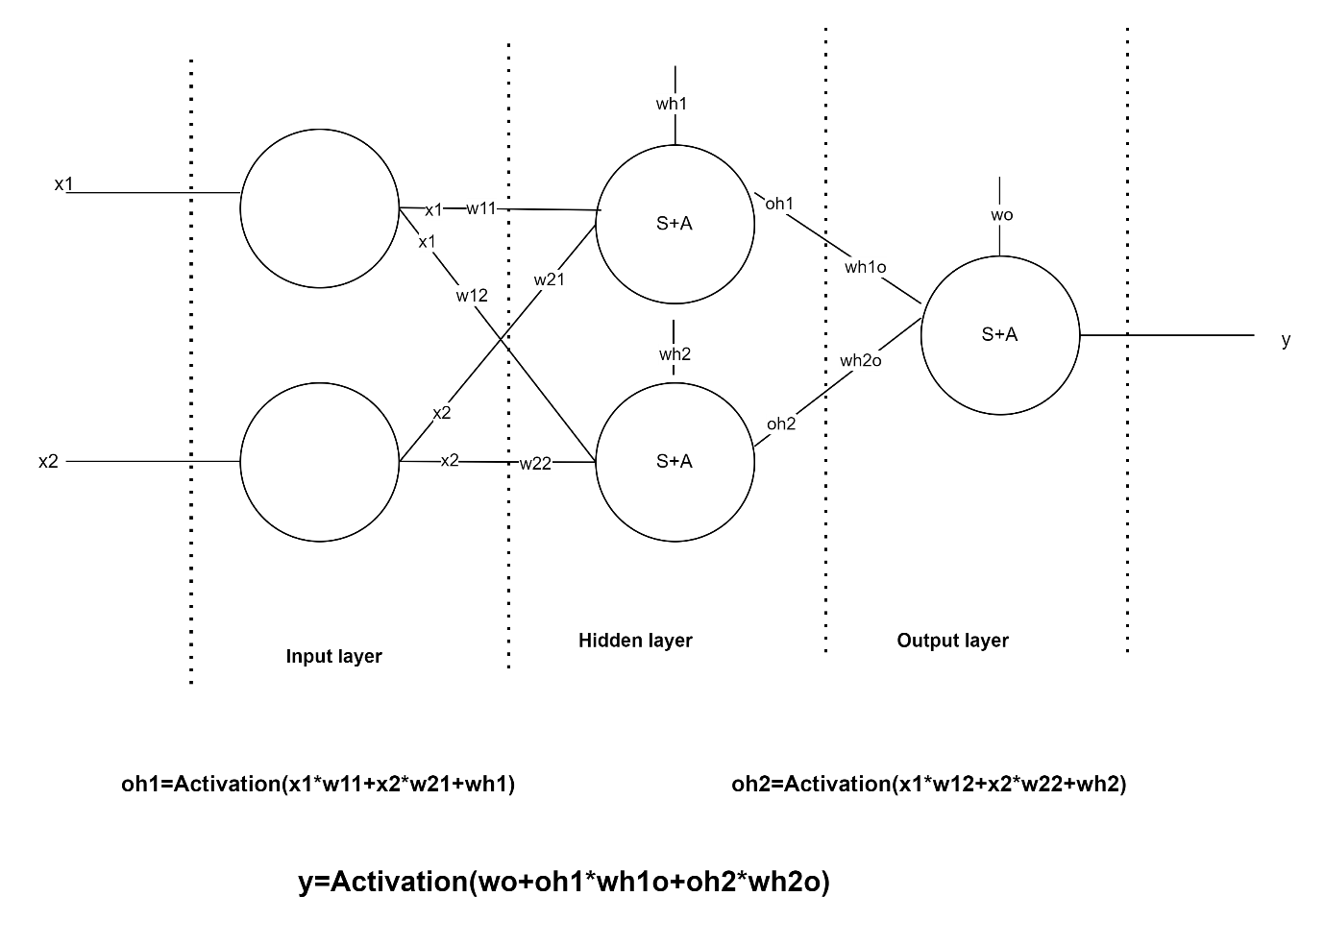

$In ANN we have 3 layers available$

$Input layer$

$Hidden layer$

$Output layer$

$$Input layer is used to pass only inputs: No bias-No weights$$

$Hidden layers will takes the inputs from input layer with multiply with weights$

$$and it takes bias also$$

$$Output layer will takes inputs from hidden layers multiply with weights and added with bias$$

$$Every neuron inside: Summation+Activation$$

$$Summation: Inputs are multiply with weights and added with bias$$

$summation: Linear combinations of inputs and bias$

$Summation: Linear regression equation$

$$Maths Calculations$$

$$at Input layer:$$

$No bias-No weights : Total parameters=0$

$At Hidden Layer:$

$Hidden layer-1 : Neuron\left(1\right): w_{h1}+w_{11}*x_{1}+w_{21}*x_{2}$

$Hidden layer-1 : Neuron\left(2\right):w_{h2}+w_{12}*x_{1}+w_{22}*x_{2}$

$Bias\left(2\right):w_{h1},w_{h2} , Weihgts\left(4\right): w_{11}, w_{21} , w_{12},w_{22}$

$$Total parameters=2+4=6$$

$Trick: Hidden layer parameters$

$inputlayer_{neurons}*Hiddenlayer_{Neurons}+Hiddenlayer_{Neurons}$

$inputlayer_{neurons}*Hiddenlayer_{Neurons}: Number of weights$

$Hiddenlayer_{Neurons}: Number of Bias$

$$At Output layer:$$

$o_{h1}=Activation\left(w_{h1}+w_{11}*x_{1}+w_{21}*x_{2}\right)$

$o_{h2}=Activation\left(w_{h2}+w_{12}*x_{1}+w_{22}*x_{2}\right)$

$y=Activation(w_{o}+w_{h1o}*o_{h1}+w_{h2o}*o_{h2})$

$Trick: output layer parameters$

$Hiddenlayer_{Neurons}* output_{layer}+output_{layer}$

$2*1+1=3$

|  |  |
| --- | --- |
| $$Layer$$ | $$Parameters$$ |
| $$Input layer$$ | $$0$$ |
| $$Hidden layer$$ | $$6$$ |
| $$Output layer$$ | $$3$$ |

$Total parameters:9$

$$Matrix Represenation:$$

$$Hidden layer$$

$${a=w}_{h1}+w_{11}*x_{1}+w_{21}*x_{2}$$

$${b= w}_{h2}+w_{12}*x_{1}+w_{22}*x_{2}$$

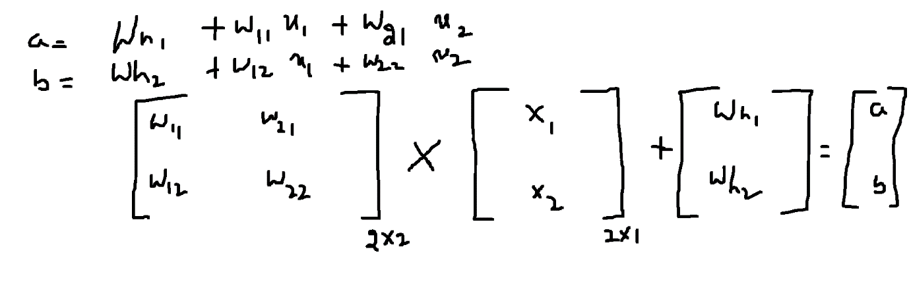

$$output layer$$

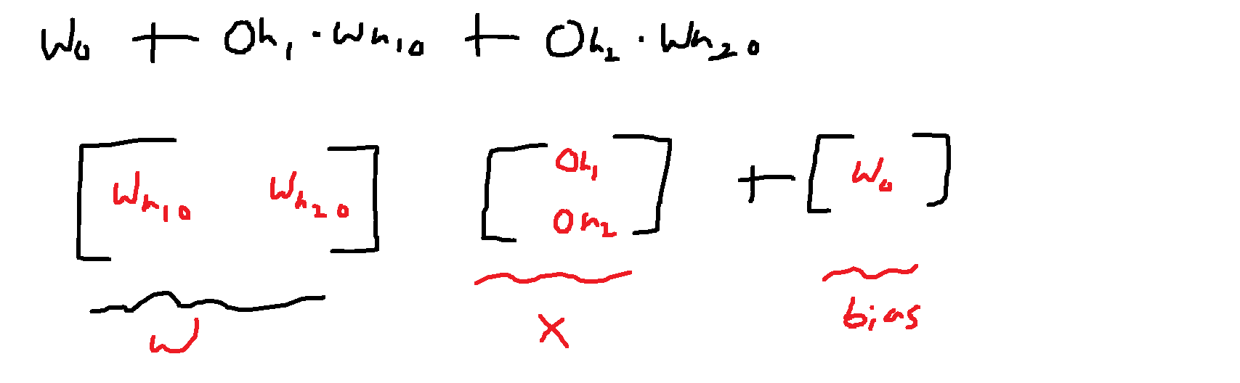

$$Example-2:$$

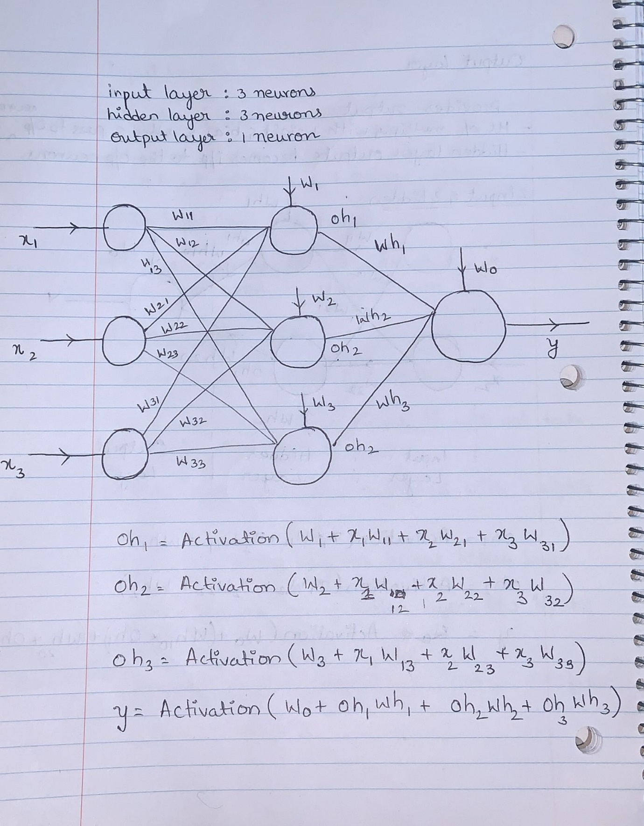

$$Example-3:$$

$$Input layer:3 Neurons$$

$$Hidden layer-1:3 neurons$$

$$Hidden layer-2:2 neurons$$

$$Output layer-1 Neurons$$



|  |  |
| --- | --- |
| $$Layer$$ | $$Parameters$$ |
| $$Input layer$$ | $$0$$ |
| $$Hidden layer1$$ | $$3*3+3=12$$ |
| $$Hidden layer2$$ | $$3*2+2=8$$ |
| $$Output layer$$ | $$2*1+1=3$$ |
| Total | 23 Parameters |

|  |  |
| --- | --- |
|  |  |
|  |  |
|  | 784*10+10= 7850 |
| $$Hidden layer2$$ | $$10*10+10=110$$ |
| $$Output layer$$ | $$10*10+10=110$$ |
| Total | 7850+110+110=8070 |

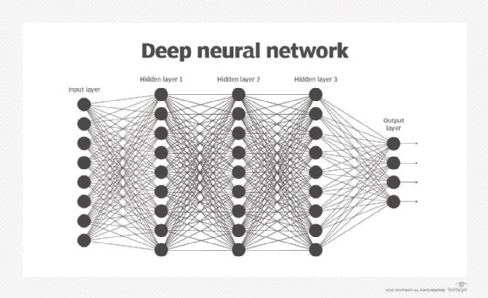

|  |  |
| --- | --- |
| $$Layer$$ | $$Parameters$$ |
| $$Input layer$$ | $$0$$ |
| $$Hidden layer1$$ | 8*9+9= 81 |
| $$Hidden layer2$$ | $$9*9+9=90$$ |
| $$Hidden layer2$$ | 9*9+9=90 |
| $$Output layer$$ | $$9*4+4=40$$ |
| Total | 81+90+90+40=301 |

$$Deep Nueral Networks:DNN$$